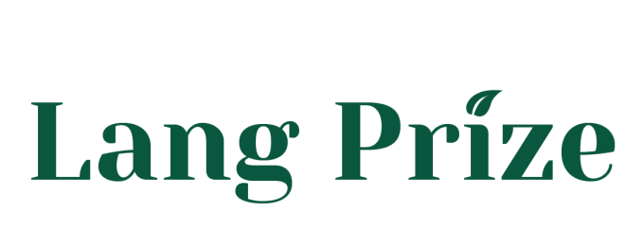
FACULTY/INSTRUCTOR
SPONSOR LETTER OF SUPPORT OF STUDENT

Deadline for submitting this Sponsor Letter is April 17, 2017.

The Norma J. Lang Prize for Undergraduate Information Research recognizes undergraduate students whose research projects:
- Make extensive use of UC Davis Library resources, services and expertise
- Advance the students' understanding of the academic research process
Students' research may be in any academic subject or major at UC Davis. Additional eligibility details can be found at: https://www.library.ucdavis.edu/langprize/eligibility

Instructions for Submission
Please save a copy of your sponsor letter as a Microsoft Word document or PDF and email it as an attachment to langprize@ucdavis.edu. If you prefer, you can send a print copy of the document to address:

Leyla Cabugos, Coordinator, Norma J. Lang Prize for Undergraduate Information Research, Shields Library, 100 NW Quad, Davis CA 95616

For more information, please email langprize@ucdavis.edu

Information
Faculty/Instructor name: Click here to enter text.
Faculty/Instructor department: Click here to enter text.
Faculty/Instructor email: Click here to enter text.
Faculty/Instructor phone: Click here to enter text.
Student name(s): Click here to enter text.
Title of paper/project: Click here to enter text.
Course number: Click here to enter text.
Course name: Click here to enter text.

Quarter course was taught: ☐ Spring 2016 ☐ Summer 2016 ☐ Fall 2016 ☐ Winter 2017

Please enter your responses below. The response fields will expand to accommodate the text entered.
- In your opinion, how did the student’s use of library collections, resources, and services contribute to making the project comprehensive, original and/or unique?
Click here to enter text.

- Please comment on the content and quality of the paper or project, especially addressing the appropriate and thorough use of research materials.
Click here to enter text.

- How much initiative did the student show in identifying most of the key resources? In what way was the student creative and flexible in using the collections?
Click here to enter text.

I agree that, if this applicant wins the prize, my sponsor letter will become permanent property of the University and may be quoted for publicity purposes.

Faculty/instructor name: Click here to enter text.
Date: Click here to enter text.

